

GENERAL SIR JOHN KOTELAWALA DEFENSE UNIVERSITY

BACHELOR OF SCIENCE IN APPLIED DATA SCIENCE COMMUNICATION

ASSIGNMENT - 02

D/ADC/24/0018 – KAUS Perera
D/ADC/24/0020 – NYM Narathota
D/ADC/24/0016 – TKBS Kumarasinghe
D/ADC/24/0037 – ADPT Athukorala

Contents

- Introduction
- Data Source & Extraction
- Data Cleaning
- User Interface & Functionality
- Trends
- Conclusion
- Resources
- Work Allocation

Introduction
The Great London Property Price Monitor is an extensive tool whose express purpose is to provide reporting on the Greater London property market. This is a project aimed at fulfilling a request of a research organization based in central London. This is intended to be a cheap means of getting data on the volatility of the residential property sales market within the region. The monitor drives users to amble through the broad part of property market factors, employing Microsoft SQL Server for archiving data and employing Power BI for visualization data based on sales trends, price distribution along geographic patterns.
This paper makes use of the UK Price Paid Dataset, which comprises 20.1m substantive residential property transactions in the UK starting from 1995. For the following analysis, the property transaction data of the years 2020, 2021, 2022, and 2023 was extracted, cleansed, and shaped for an SQL database analysis. From urban and suburban, one to four, five or more bedrooms, to detached and terraced to semi-house, flat, bungalow, and more and affordable, everything is included; as such, it provides significant information relating to market transactions within the 32 boroughs of Greater London.
In this report, the process of creating the Greater London Property Price Monitor is outlined in detail, including how the data was imported from multiple sources into an SQL database, how this database was designed, and how self-sustaining Power BI visuals were created. It also presents the conclusions and suggestions based on the analysis to offer valuable and practical suggestions to property investors, estate agents, and policymakers concerned with the emerging property market.

Data Source and Extraction
In this case, a real estate agency in Greater London was examined using data obtained from the UK Price Paid Dataset. This is a dataset that has been a government institution in the United Kingdom and put in the public domain and it contains all the property sale transactions that took place within the United Kingdom from the year 1995 to the present. For this dataset, we have a set of key input features that involve unique transaction identifiers, price level, transfer date, type of property, and buyer category. This metadata could be inspected from the official home page of the data portal of the United Kingdom. These data belong to this project that is performed from 2020 to 2023. These datasets were downloaded from the government site using the link: UK Price Paid Data Downloads
The data sources presented for this project are the years 2020, 2021, 2022, and 2023. This raw data was stored in CSV format which was then exported into a behavioral platform MS SQL Server. To simplify and ease data analysis, each year was in a different table (for instance, pp-2020, pp-2021, pp-2022, pp-2023). The data will be rich since it is inclusive of Greater London property market transactions by type, price, and geographical location. Trend analysis and visualization of more advanced levels can be continued by Power BI on this dataset.
Step-by-Step Process for Extracting the Data:
- First, we have to download all the datasets (2020,2021,2022 and 2023) in CSV format from the UK Government repository.
- Then, we have to import the CSV files into the SQL Server using the Import Data wizard
- Finally, we have to load the data into separate tables for each year.
(Each table contained column fields for transaction ID, price paid, property type, date of transfer, and address-related fields.)

Example of selecting data from the pp-2023 table:
This step was followed for all years (2020-2023) so that all data was available for analysis in the SQL database.

Data Cleaning
After importing the raw data into the SQL Server database, we faced some data quality issues: Certain key columns corresponded to missing values. The actions we have done to clean up the data and make it fit for analysis are mentioned below.
- Handling Missing Values:
  - Some columns, such as Secondary Addressable Object Name (SAON), Primary Addressable Object Name (PAON), Locality, and Street, contained NULL values in the initial dataset. To normalize records that appeared with missing values and to ensure the data cleaning process would be successful in the long run, we replaced all the missing values (NULL values) by using 'N/A'.
The SQL queries used to perform this replacement are as follows:

  - The same process was done to all four datasets.

- Verification of Data Cleaning:
After doing the modifications, we had to check whether all the Null values were replaced by ‘N/A’. For that, we used the below-mentioned code.

  - This process was repeated for all datasets from 2020 to 2023.
- Type Conversion:
  - In addition, data types in these datasets were reviewed to fit into the aesthetic nature of the visualizations adopted within Power BI. For example, numerical values would always get the price type, which means date converted to date format in Power BI to allow for time series visualizations.

It was through these cleaning steps that all datasets were prepared for analysis and visualization in the Power BI dashboard. After going through all these processes, we merged all four tables into one so that they can be accessed easily when it comes to making the Power BI dashboard.

User Interface & Functionality
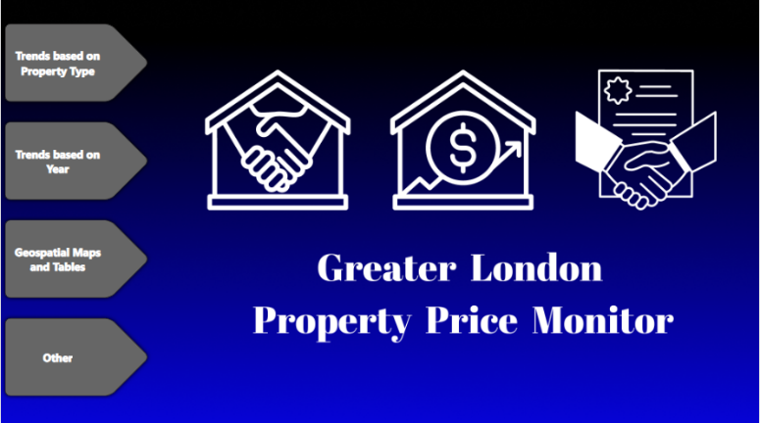
The dashboard has a user-friendly interface that is easy to navigate. The first page is the home page of the dashboard, and it has a dashboard design where the user can choose which page or section they want to see. It takes the user to their chosen page by clicking on an option.
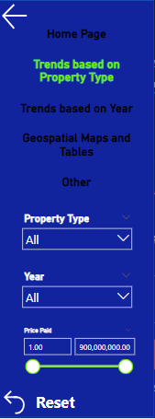
On the top of the page, there is a menu icon that you can click on where you get a pop-up filter pane. You can use filters to choose the year, property type, and price range for easier access. You can reset everything to its original state by clicking on the reset icon in the filter pane. You can navigate through the pages by clicking on the page navigation buttons inside the menu. We used it to take percentages of the most common outcomes. It is through the combination of these navigation options, filtering capabilities, and detailed view functionality, that the user will be able to cover and analyze the data presented on the dashboard effectively and efficiently.

Trends
Page 1 - Overview of Property Transactions by Type
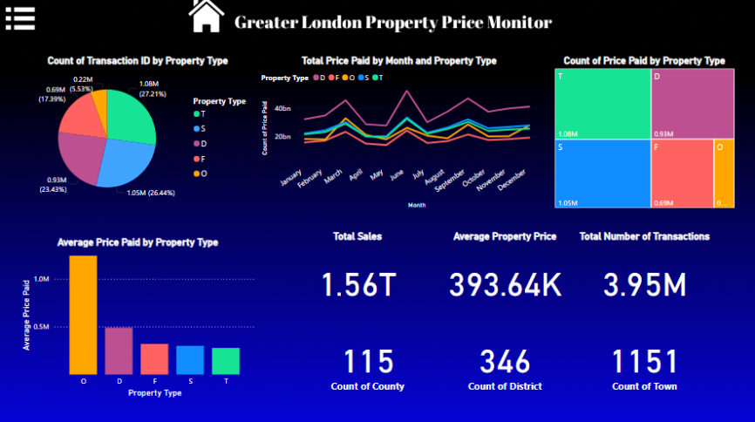

- Total Sales and Transaction Overview:

  - Total Sales: £1.56T, indicative of a sizeable real estate market.
  - Average Property Price: £393.64K, showing that properties within the city are somewhat highly valued when compared to other areas.
  - Total Number of Transactions: 3.95M, which indicates quite a volume of transactions during the period under review.
  - Count of Counties (115), Districts (346), and Towns (1151) show the wide geographic spread of the data.

- Transaction Distribution by Property Type:

  - From the pie chart, it can be observed that Flats (F) are the most frequent property type, constituting 27.21% of transactions, while Semi-Detached (S) constitutes 26.44%.
  - Among other property types, detached (D) has a share of 23.43% of the transactions, and Other (O) property type contributes 13.46%.
  - Least transactional properties are terraced, which accounted for about 5.3% of the transactions.

- Total Price Paid by Month and Property Type:

- The line graph shows the monthly variation in the total price paid for each property type:
- There are spikes in the middle of the year, say from April to June, and then again towards September and November for all the property types
- Flats (F) and Semi-Detached (S) properties lead these periods of high sales.

- Average Price Paid by Property Type:

- Other (O) properties have the highest average price, over £1M; this could include some very highly valued or even luxury properties.
- Next come Detached (D) and Flats (F), which are averagely lower in price.
- The Terraced properties are amongst the cheapest as most of them are smaller or in less prestigious areas.

- Number of Prices Paid by Property Type (Treemap):

- The graph above reassures us again from the data that Flats and Semi-Detached homes are the dominant ones when it comes to the aspect of price paid.
- Some detached properties also receive higher prices but are a bit smaller in transaction number.

Page 2 - Historical Trends in Transactions and Prices
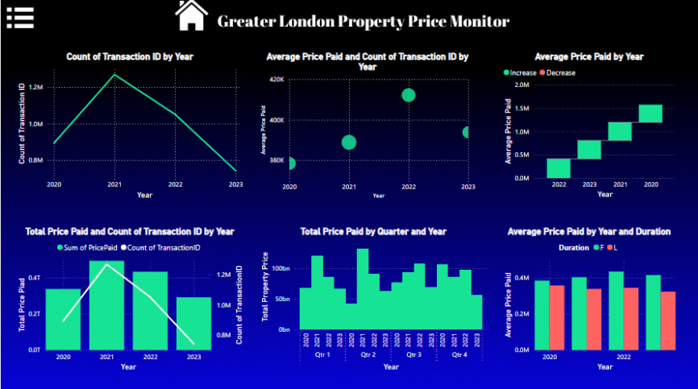

- Count of Transactions by Year:
  - There is a peak in 2021 with over 1.2M transactions, followed by a sharp decline in 2022 and 2023.
  - The drop in transaction volume in 2023 could be related to market cooling or macroeconomic factors such as rising interest rates or decreased housing demand.
- Average Price Paid and Count of Transactions by Year:
  - The bubble chart indicates that 2022 saw a rise in both the number of transactions and the average price paid. However, 2023 shows a lower number of transactions with a higher average price, indicating a possible market contraction where fewer, higher-value properties were sold.

- Average Price Paid by Year:
  - There has been a steady increase in average property prices from 2020 to 2023. The most significant jump happened from 2021 to 2022, where the average price nearly doubled.
  - Despite the fall in the number of transactions, the price levels continued to rise, suggesting strong demand or reduced housing supply.
- Total Price Paid and Count of Transactions by Year:
  - Like earlier trends, 2021 saw the highest transaction counts and total prices paid. However, by 2022 and 2023, the number of transactions decreased, but the total prices remained robust, aligning with the rise in average property prices.
- Total Price Paid by Quarter and Year:
  - Each year shows distinct fluctuations in total prices across quarters, with Q2 and Q4 consistently having higher prices, suggesting seasonality in the market (possibly more sales in spring and fall).
  - In 2023, Q2 had the highest total price, reinforcing the idea that fewer transactions are being made, but they are of higher value.
- Average Price Paid by Year and Duration:
  - This bar chart splits data by Freehold (F) and Leasehold (L) properties.
  - Freehold properties tend to have a higher average price across all years, particularly in 2022, with leasehold properties showing more gradual price increases.

Page 3
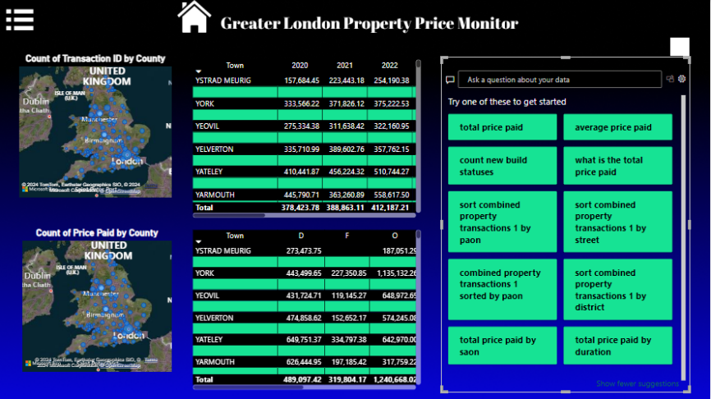
Transaction Volume by County
- Regional Disparities: The count of transactions deviates quite a lot from one county to the other which points out the geographical distribution of markets.
- West Yorkshire Dominance: West Yorkshire records the largest number of transactions indicating that this region has great demand for properties.

The distribution of the type of property by county looks as follows.
- Variations Across Counties: The distribution of property types (D, F, O) differs from one county to another because of the difference in the preferences and demands of people in different areas.
- Dominance of Houses and Flats: In most cases, Houses (D) and Flats (F) remain the typical leading submarkets in most counties.
Page 4
This decomposition tree shows a summary of all the other trends we mentioned before.
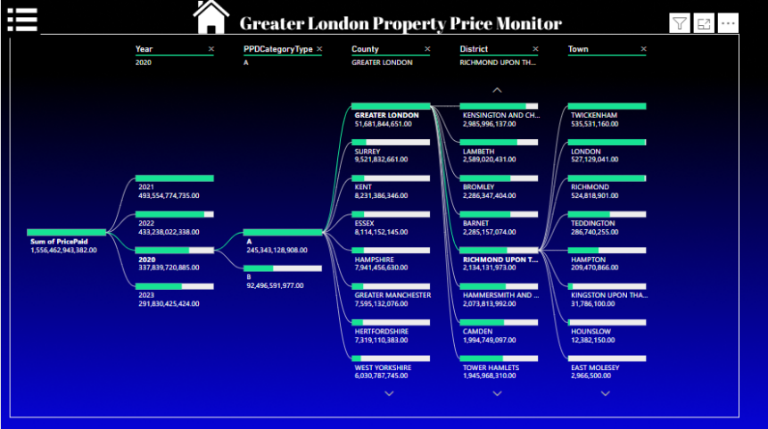

Conclusion
The bigger picture analysis of the Greater London Property Price Monitor led to the extraction of some additional deeper critical understanding of the property market fixes in the region. Using transaction volume, average price paid, total price paid, property types, and geographic locations, we have identified the following key real estate trends:
- More Costly Properties: Consumers in Greater London have further paid slightly higher amounts for each property in recent years.
- Regional differences: Evidently, the real estate prices are exhibited with considerable differences in Greater London between counties and boroughs as well as the overall volumes of transactions.
- Property Type Preferences: The notified houses and flats have continuously formed the largest proportion of the property dealings, as evident from the evidence that presented a clear preference.
- Explanatory Factors: Property prices could still be driven by the economic conditions, governmental actions, and other factors that characterize the market.
All these trends are very crucial to know to a various extent for the different buyers, sellers, investors, and policymakers. These insights will create a base for decision-making, investment planning, and the formation of policies relating to the property market in Greater London.

Work Allocation
Group Member | Task
D/ADC/24/0016 | Doing the SQL Part
D/ADC/24/0020 | Making the Power BI Dashboard and Report

